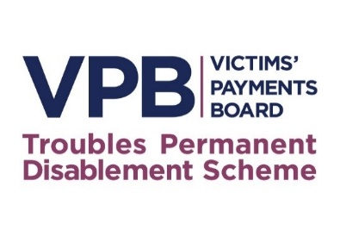

GUIDANCE NOTE (GN19/24)
Evidence on Oath
Statutory Authority
- Under Schedule 1 paragraph 2(3) to the Victims’ Payments Regulations 2020, the Victims’ Payment Board may do anything it considers to be appropriate for facilitating, or to be incidental or conducive to, the exercise of its functions.

- The President of the Victims’ Payment Board under Schedule 1 paragraph 4(3) to the Regulations is responsible for ensuring the efficient and effective discharge of the Board’s functions.

- Under Schedule 1 paragraph 1(1) to the Regulations, the Board has been established as a body corporate and under Schedule 1 paragraph 1(3) to the Regulations and section 19(1)(a)(v) of the Interpretation Act (NI) 1954, it has the right to regulate its own procedure and business.

- Under Schedule 1 paragraph 11(2) to the Regulations, the Board may administer oaths for the purposes of these Regulations.

- This Guidance Note is issued in accordance with Regulation 4 of the Victims’ Payment Regulations 2020 and the principles set out therein, in particular the need to be responsive to the needs of victims; the need to be transparent and communicate effectively; and the need for the Scheme to be straightforward and simple to navigate.

- In accordance with regulation 39(2) an appeal panel, may, if it considers it necessary in the interests of justice to do so, direct that evidence at an oral hearing is to be given on oath.

- Where a first instance panel considers an oral hearing is necessary, having regard to the exceptional circumstances of the application, the panel, may, if it considers it necessary in the interests of justice direct that evidence at an oral hearing is to be given on oath.

- In terms of what a panel may consider necessary in the interests of justice when directing that evidence is to be given on oath, this could include an important issue of evidence turning on credibility, or where there is a need to emphasise gravity. The list is not exhaustive.

- Where evidence is required to be given on oath the panel will explain the reasons for the request and will explain to the applicant/appellant the method of taking the oath or of affirming and the manner in which the evidence will be taken. The panel will further explain that anyone giving evidence on oath who makes a statement that they know to be false or does not believe to be true may be guilty of committing perjury. Where appropriate, the panel will adjourn to enable the applicant/appellant to have the opportunity to receive advice in respect of giving evidence on oath.

